N Queen Problem | Return all Distinct Solutions to the N-Queens Puzzle
Problem Statement: The n-queens is the problem of placing n queens on n × n chessboard such that no two queens can attack each other. Given an integer n, return all distinct solutions to the n -queens puzzle. Each solution contains a distinct boards configuration of the queen's placement, where ‘Q’ and ‘.’ indicate queen and empty space respectively.
Input: N = 4
Output: [[".Q..","...Q","Q...","..Q."],["..Q.","Q...","...Q",".Q.."]]
Explanation: There exist two distinct solutions to the 4-queens puzzle as shown below
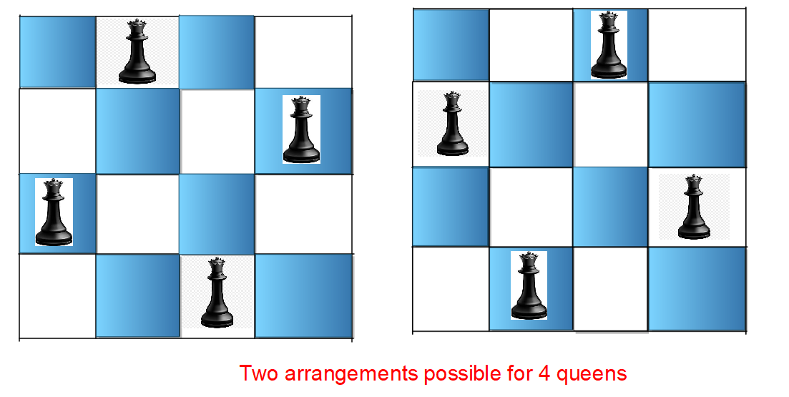
Input: N = 1
Output: [["Q"]]
Explanation : There is only one way to place 1 queen on 1x1 chessboard.

Algorithm
Instead of checking every row, column, and diagonal every time we place a queen (which is slow), we use precomputed boolean arrays to instantly check if a queen can be safely placed. Each array acts like a hash for fast lookup. A row array keeps track of which rows already have a queen. Two diagonal arrays (lowerDiagonal and upperDiagonal) keep track of the diagonals that are under attack. This avoids repetitive scanning and makes the backtracking highly efficient.
- Initialize three boolean arrays, one for rows, one for lower diagonals, and one for upper diagonals.
- Start placing queens column by column from left to right using backtracking.
- For a given column, iterate through all rows and check if placing a queen at (row, col) is safe using the hash arrays.
- To check if placing a queen is safe, ensure the corresponding row, lower diagonal (row + col), and upper diagonal (n - 1 + col - row) are not already marked as attacked in the boolean arrays.
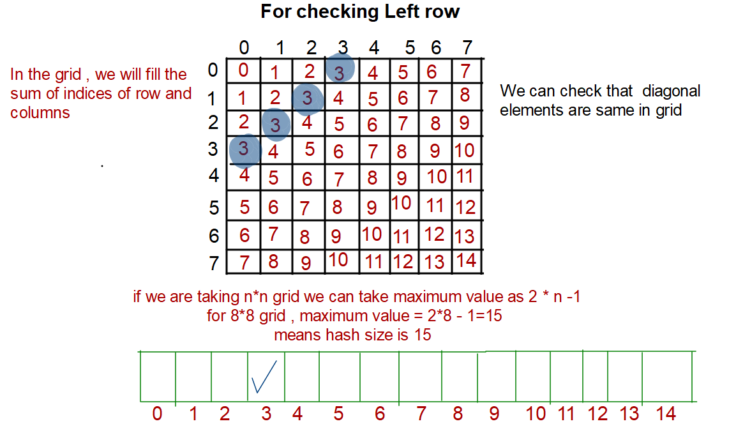
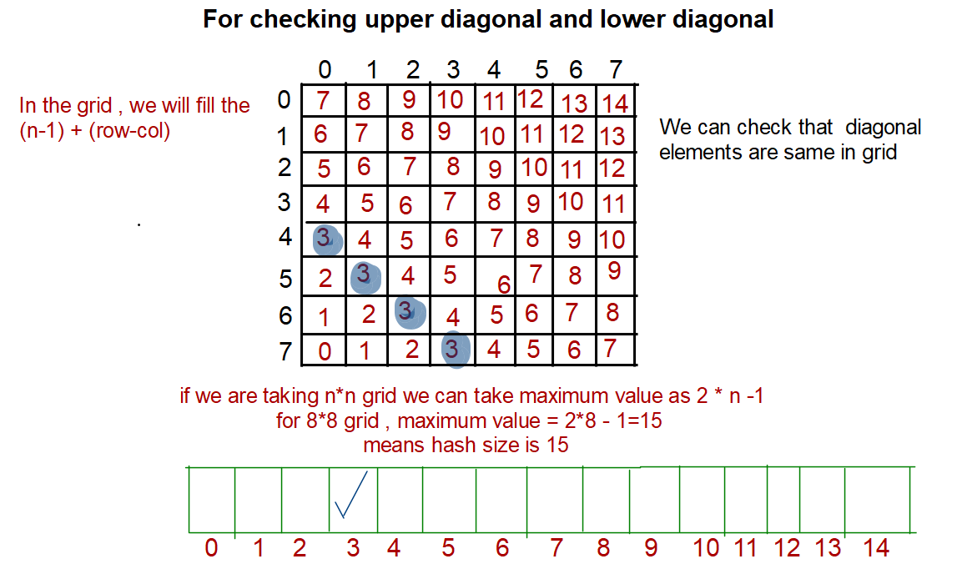
- If safe, place the queen and mark the corresponding row and diagonals as attacked.
- Recurse to the next column to place the next queen.
- When backtracking, remove the queen and unmark the row and diagonals to try other configurations.
- Count or store the solution if all columns are successfully filled with safe placements.
import java.util.*;

class Solution {
// Function to solve N-Queens
public void solve(int col, char[][] board, int n,
int[] leftRow, int[] upperDiagonal, int[] lowerDiagonal, List<List<String>> res) {
// If all queens are placed
if (col == n) {
List<String> temp = new ArrayList<>();
for (int i = 0; i < n; i++) {
temp.add(new String(board[i]));
}
res.add(temp);
return;
}

// Iterate through rows
for (int row = 0; row < n; row++) {
// Check safety
if (leftRow[row] == 0 && lowerDiagonal[row + col] == 0 &&
upperDiagonal[n - 1 + col - row] == 0) {

// Place queen
board[row][col] = 'Q';
leftRow[row] = 1;
lowerDiagonal[row + col] = 1;
upperDiagonal[n - 1 + col - row] = 1;

// Recurse
solve(col + 1, board, n, leftRow, upperDiagonal, lowerDiagonal, res);

// Backtrack
board[row][col] = '.';
leftRow[row] = 0;
lowerDiagonal[row + col] = 0;
upperDiagonal[n - 1 + col - row] = 0;
}
}
}
public List<List<String>> solveNQueens(int n) {
List<List<String>> res = new ArrayList<>();
char[][] board = new char[n][n];
for (char[] row : board) Arrays.fill(row, '.');
int[] leftRow = new int[n];
int[] lowerDiagonal = new int[2 * n - 1];
int[] upperDiagonal = new int[2 * n - 1];
solve(0, board, n, leftRow, upperDiagonal, lowerDiagonal, res);
return res;
}
}

Complexity Analysis
Time Complexity: O(N!), we try all possible permutations of placing the queens.
Space Complexity: O(N), three boolean arrays are stored to check for safety.

